# Informações do estudo

Referência: Chinchanikar 45

Grandeza: Força

Tipo: Fz

Material: AISI 4340 (45 HRC)

Ferramenta: KC9110

Número de experimentos: 20

Observações:  
Tool holder: PCBNR 2020K12  
Diameter: 90 mm  
Piezo-electric dynamometer: KISTLER Type 9257A  
Surface roughness tester: Qualitest TR100

# Unidades

Velocidade: m/min

Avanço: mm/rev

Profundidade de corte: mm

Força: N

# Dados de teste

|  |  |  |  |
| --- | --- | --- | --- |
| Força | n | f | a |
| 1165.0 | 150.0 | 0.2 | 2.5 |
| 492.0 | 175.0 | 0.15 | 1.0 |
| 1296.0 | 125.0 | 0.25 | 2.0 |
| 793.0 | 150.0 | 0.2 | 1.5 |

# Dados de treino

|  |  |  |  |
| --- | --- | --- | --- |
| Força | n | f | a |
| 806.0 | 150.0 | 0.2 | 1.5 |
| 1118.0 | 175.0 | 0.25 | 2.0 |
| 783.0 | 150.0 | 0.2 | 1.5 |
| 885.0 | 100.0 | 0.2 | 1.5 |
| 615.0 | 150.0 | 0.1 | 1.5 |
| 558.0 | 125.0 | 0.15 | 1.0 |
| 759.0 | 200.0 | 0.2 | 1.5 |
| 894.0 | 125.0 | 0.15 | 2.0 |
| 799.0 | 125.0 | 0.25 | 1.0 |
| 784.0 | 150.0 | 0.2 | 1.5 |
| 1088.0 | 150.0 | 0.3 | 1.5 |
| 822.0 | 150.0 | 0.2 | 1.5 |
| 609.0 | 175.0 | 0.25 | 1.0 |
| 342.0 | 150.0 | 0.2 | 0.5 |
| 927.0 | 175.0 | 0.15 | 2.0 |
| 830.0 | 150.0 | 0.2 | 1.5 |

# RN

Número de neurônios: 53

Taxa de aprendizado: 1.000000e-03

Número de épocas: 498

2° camada: False

Função de ativação: relu

# Erros

**Dados de teste**

* Erro relativo médio: 5.48
* Coeficiente de correlação: 0.97
* Coeficiente de determinação: 0.94
* MSE: 10035.79
* RMSE: 100.18

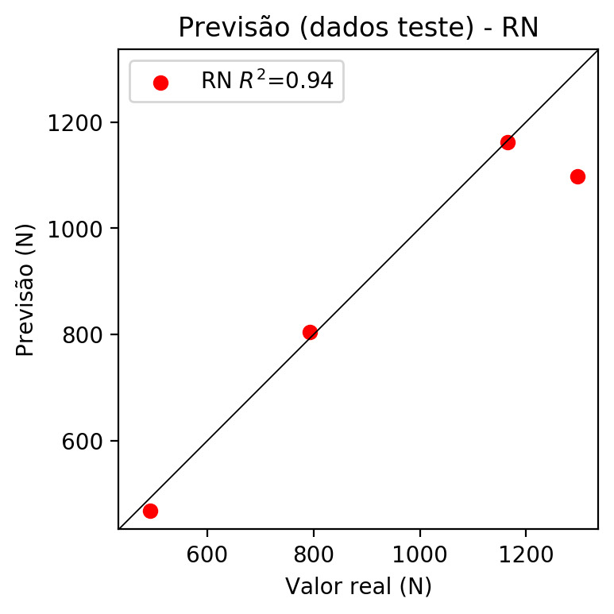

**Dados de treino**

* Erro relativo médio: 0.91
* Coeficiente de correlação: 1.0
* Coeficiente de determinação: 1.0
* MSE: 122.22
* RMSE: 11.06

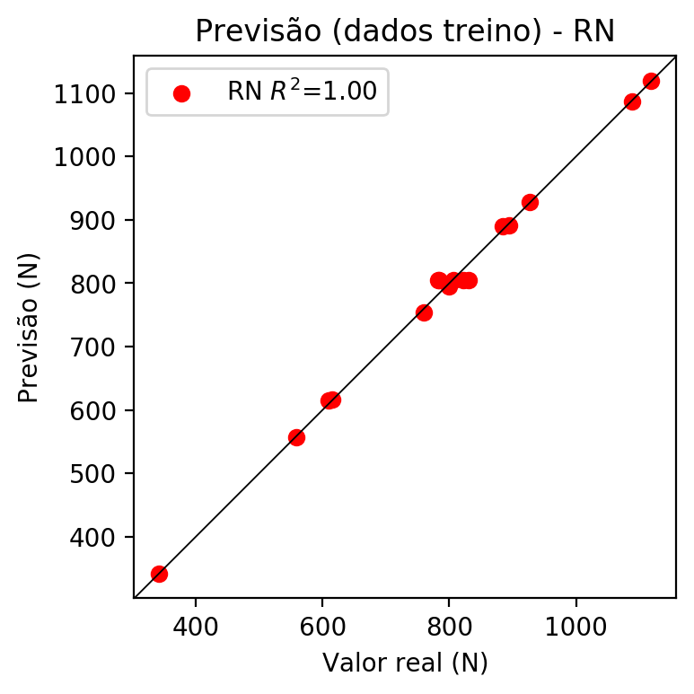

# Pesos

Pesos - camada oculta 1

[[ 0.10856365 0.01400852 -0.09959935 -0.27848902 0.08020913 -0.03385087  
 0.1587599 -0.24733233 -0.0211398 0.02023983 -0.17474827 0.08407177  
 0.01267 0.18517502 -0.04148498 -0.0169178 -0.00315649 0.08661655  
 -0.16073821 0.17562044 0.16944577 0.11542979 0.14749767 0.0483853  
 -0.08342193 -0.10132613 0.21422169 -0.12404981 0.13230582 -0.12120587  
 0.1761269 -0.19323407 0.00070967 -0.13738807 0.09060579 -0.07699388  
 -0.06617191 0.05970699 -0.1245982 0.10365977 0.04293095 0.05922863  
 0.16263923 0.18478654 0.0213621 0.17841743 0.28110158 -0.04866675  
 0.1548326 0.19258338 0.09344895 0.09873794 -0.00223887]  
 [-0.03431635 -0.10600274 0.03301233 0.2472441 0.10220836 -0.28184727  
 -0.43126562 0.44501892 -0.30973765 -0.19755228 0.03569598 0.4363714  
 -0.27596083 -0.05749737 0.02146231 -0.2835586 -0.15405482 -0.1134482  
 0.04152268 0.00485597 -0.15520427 0.15145242 -0.07954921 0.23199807  
 0.25429833 0.02523601 -0.02035017 0.40348682 -0.24096061 -0.3610761  
 -0.06602465 -0.12800136 0.27460623 -0.0465634 -0.21554568 -0.3545259  
 0.41305113 -0.0291284 -0.2787578 -0.25269914 0.20092201 -0.05673913  
 -0.13876654 -0.23424093 0.21012452 -0.03963073 -0.10218498 0.18407242  
 -0.1848466 0.4094802 -0.1532291 -0.20718738 -0.23412436]  
 [-0.00329709 -0.08628956 0.03497856 0.21441099 0.09530064 -0.306385  
 0.25846335 0.40174422 0.22727343 0.42545873 -0.08080257 -0.0224665  
 -0.03080571 -0.35260758 0.0264735 -0.3224177 -0.02769105 -0.24120496  
 0.1555357 0.09582622 0.38622496 0.02533138 -0.4214964 -0.02016634  
 0.14891696 -0.07100148 0.10569943 0.25823626 0.38844234 0.3341204  
 -0.29745626 0.06647557 -0.38218182 0.10231411 -0.16752379 -0.39000967  
 0.20597436 -0.02659517 -0.08902343 -0.26931387 0.40479228 0.25819424  
 0.36430332 0.20954484 0.39632723 -0.4044469 -0.20325622 -0.3141426  
 -0.11882611 -0.20880596 0.34236142 0.3548655 -0.02755376]]

Bias - camada oculta

[-0.09212636 -0.05136405 -0.11535148 0.26780608 -0.09494594 -0.13130279  
 -0.01529891 0.22235394 -0.11288771 -0.07431292 -0.1186261 -0.0994085  
 -0.06265365 0.12464865 -0.09297648 -0.09717841 -0.04179395 -0.01046161  
 -0.1264519 -0.09535682 -0.09623234 -0.09446318 0.14340325 -0.09452505  
 -0.0239431 -0.11538635 -0.09799995 -0.02311182 -0.09469973 -0.15962234  
 0.14309272 -0.15132394 -0.11645314 -0.1788368 0.00398187 -0.1910277  
 -0.09529726 -0.07865659 -0.06461894 0.07753332 -0.06352399 -0.08899324  
 -0.09588105 -0.09643131 -0.05328071 0.13130859 0.19754069 -0.16564886  
 -0.10048473 -0.10987613 -0.09223101 -0.09263684 -0.03672535]

Pesos - camada saída

[[ 0.13864979 0.01450303 -0.13306539 0.3040036 0.11368286 -0.24201615  
 -0.18989585 0.25984403 -0.08491896 0.05686767 -0.19827645 0.13228422  
 0.05781354 -0.21465963 -0.07695848 -0.2242207 0.03243171 -0.2505269  
 -0.17030983 0.19054392 0.19332772 0.13390537 -0.2200222 0.09443074  
 0.06645984 -0.12821667 0.23053914 0.2461647 0.15832543 -0.11389706  
 -0.23871954 -0.20233706 -0.4483694 -0.14912277 -0.03618788 -0.27915424  
 0.20725983 0.08770116 -0.09564228 -0.19965363 0.12874892 0.0911962  
 0.18633619 0.20486705 0.13639607 -0.21406928 -0.22195293 -0.1807221  
 0.18693818 0.21649402 0.12186107 0.12645982 0.02942622]]

# Iterações

|  |  |  |  |  |  |  |
| --- | --- | --- | --- | --- | --- | --- |
| Média | Desvio | n | ln | 2° camada | Função | Épocas |
| -0.0756 | 0.0519 | 10 | 0.1 | False | relu | 38 |
| -0.123 | 0.0672 | 17 | 0.1 | True | relu | 716 |
| -0.1219 | 0.0927 | 7 | 0.01 | True | tanh | 130 |
| -0.198 | 0.0891 | 19 | 0.001 | False | tanh | 282 |
| -0.0712 | 0.0332 | 29 | 0.001 | False | relu | 469 |
| -0.1203 | 0.0886 | 88 | 0.1 | False | tanh | 926 |
| -0.1116 | 0.0842 | 95 | 0.0001 | True | relu | 984 |
| -0.0896 | 0.0891 | 10 | 0.01 | True | tanh | 865 |
| -0.5271 | 0.2872 | 58 | 0.001 | True | relu | 8 |
| -0.1343 | 0.0632 | 9 | 0.01 | False | tanh | 514 |
| -0.0642 | 0.0477 | 73 | 0.0001 | True | relu | 729 |
| -0.1769 | 0.1344 | 22 | 0.001 | True | relu | 543 |
| -0.0821 | 0.0546 | 25 | 0.1 | True | relu | 562 |
| -0.0465 | 0.0244 | 53 | 0.001 | False | relu | 498 |
| -0.0665 | 0.0495 | 83 | 0.01 | True | relu | 337 |
| -0.1557 | 0.0597 | 99 | 0.01 | False | tanh | 16 |
| -0.0593 | 0.0438 | 23 | 0.01 | False | relu | 472 |
| -0.0812 | 0.1084 | 24 | 0.001 | True | relu | 778 |
| -0.0547 | 0.0418 | 58 | 0.01 | True | tanh | 382 |
| -0.2815 | 0.281 | 35 | 0.1 | False | tanh | 596 |

# RL

# Coeficientes

[ 0. -0.1480606 0.45503019 0.87948023]

# Erros

**Dados de teste**

* Erro relativo médio: 7.42
* Coeficiente de correlação: 0.97
* Coeficiente de determinação: 0.95
* MSE: 5844.75
* RMSE: 76.45

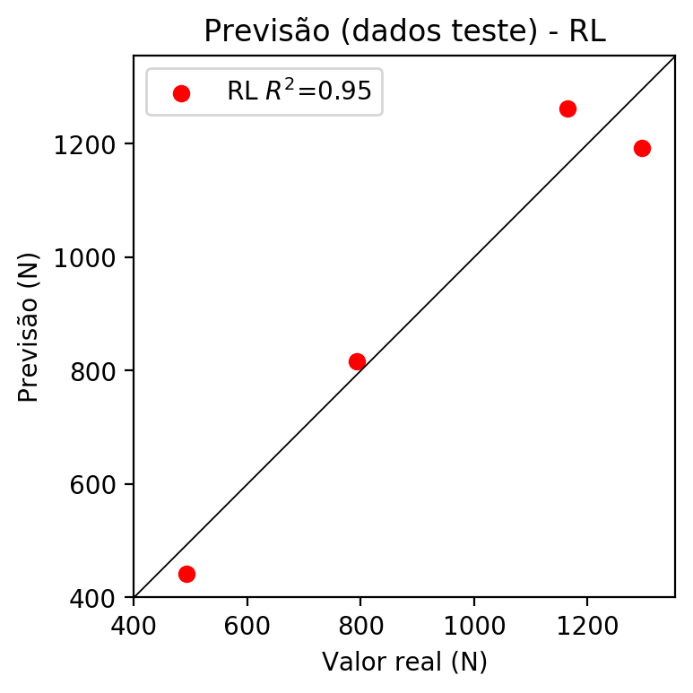

**Dados de treino**

* Erro relativo médio: 4.27
* Coeficiente de correlação: 0.98
* Coeficiente de determinação: 0.96
* MSE: 1302.29
* RMSE: 36.09

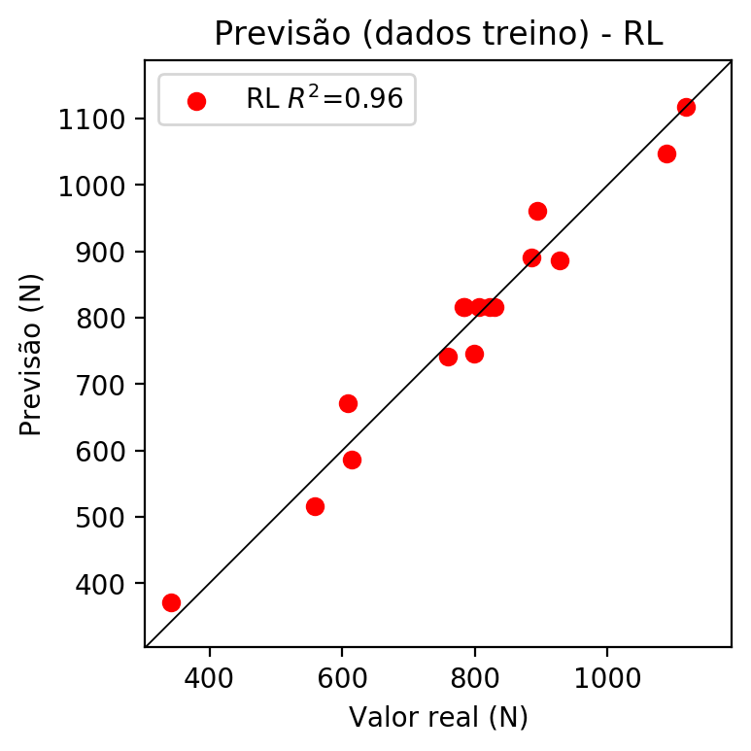

# RP2

# Coeficientes

[ 0. -0.14090003 0.44786961 0.8365168 0.0153981 -0.05910152  
 0.14288529 0.04211833 0.013813 -0.03555149]

# Erros

**Dados de teste**

* Erro relativo médio: 6.78
* Coeficiente de correlação: 0.98
* Coeficiente de determinação: 0.96
* MSE: 6254.09
* RMSE: 79.08

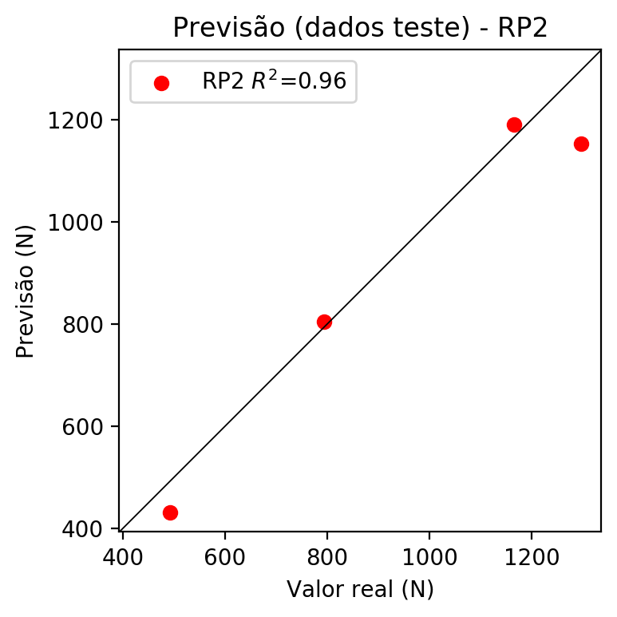

**Dados de treino**

* Erro relativo médio: 1.27
* Coeficiente de correlação: 1.0
* Coeficiente de determinação: 1.0
* MSE: 155.89
* RMSE: 12.49

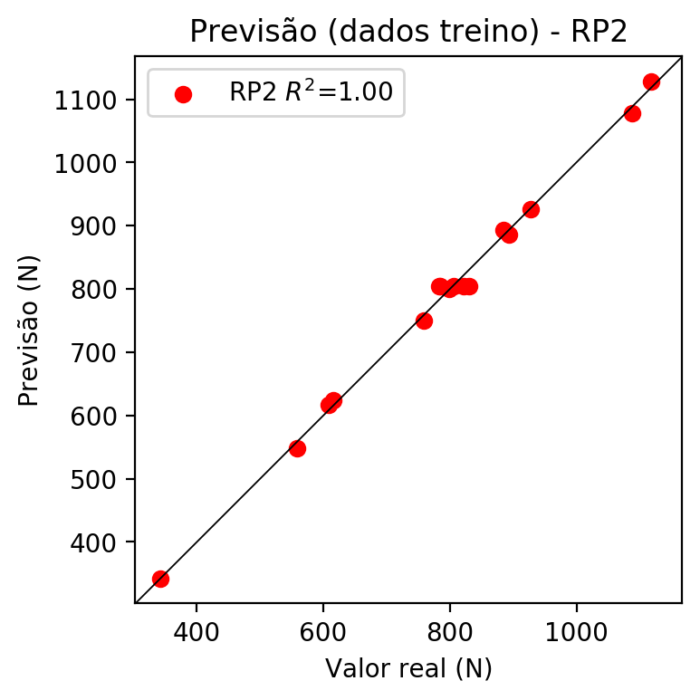

# RP3

# Coeficientes

[ 4.99600361e-16 8.74134314e-03 4.31914946e-02 1.22831008e-01  
 1.53980978e-02 -8.31251301e-02 1.18861682e-01 4.21183263e-02  
 3.78366071e-02 -1.15278829e-02 -2.80228301e-02 3.86546981e-02  
 1.40724953e-01 2.31814033e-02 1.56198248e-01 2.31814033e-02  
 8.91955051e-02 1.40724953e-01 3.86546981e-02 1.61272428e-01]

# Erros

**Dados de teste**

* Erro relativo médio: 15.88
* Coeficiente de correlação: 0.84
* Coeficiente de determinação: 0.71
* MSE: 31184.63
* RMSE: 176.59

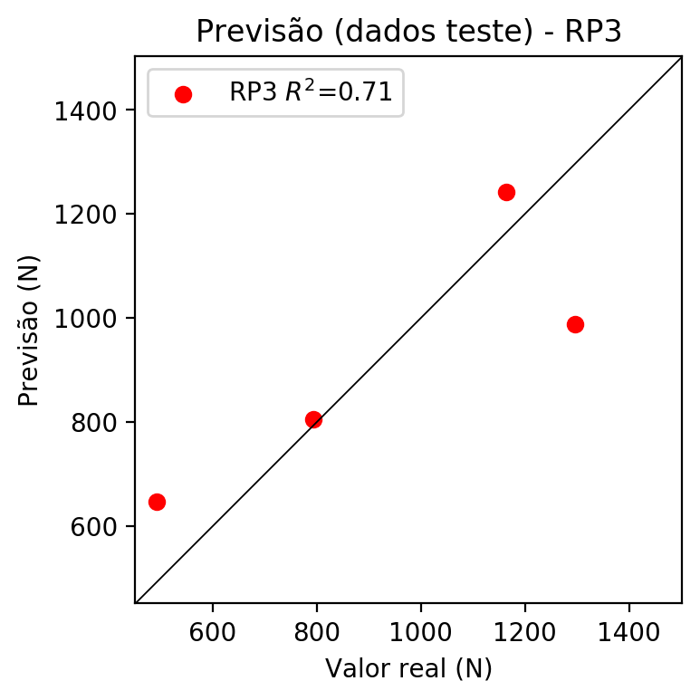

**Dados de treino**

* Erro relativo médio: 0.67
* Coeficiente de correlação: 1.0
* Coeficiente de determinação: 1.0
* MSE: 115.0
* RMSE: 10.72

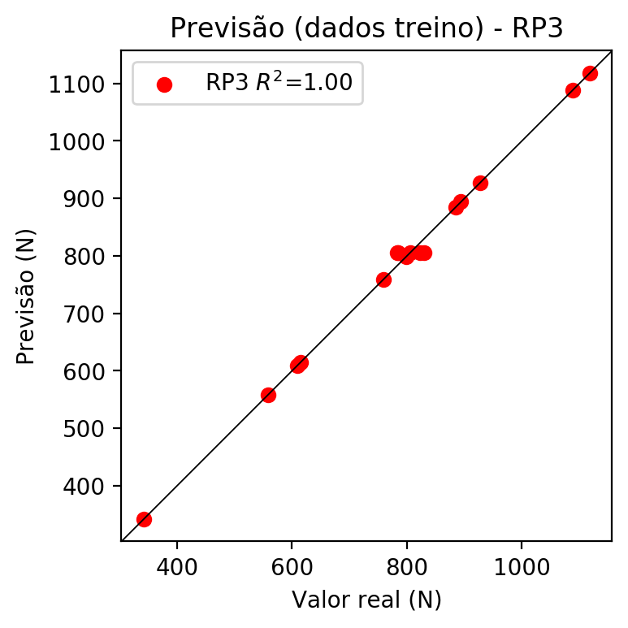

# RP4

# Coeficientes

[ 2.25514052e-17 9.28715736e-03 4.26456804e-02 1.23153788e-01  
 4.30891234e-03 -1.40620139e-02 2.45553303e-02 5.44292735e-03  
 5.40341655e-03 2.21686208e-03 -2.81377383e-02 3.77521895e-02  
 1.44679713e-01 2.40839119e-02 1.58347990e-01 2.40839119e-02  
 8.93104134e-02 1.44679713e-01 3.77521895e-02 1.50941353e-01  
 2.33456536e-03 -1.66986415e-02 2.91594548e-02 6.04425609e-03  
 6.41655715e-03 6.04425609e-03 -1.66986415e-02 2.91594548e-02  
 -1.66986415e-02 2.91594548e-02 7.72113663e-03 6.41655715e-03  
 6.04425609e-03 6.41655715e-03 -7.60267339e-03]

# Erros

**Dados de teste**

* Erro relativo médio: 14.67
* Coeficiente de correlação: 0.86
* Coeficiente de determinação: 0.74
* MSE: 31336.83
* RMSE: 177.02

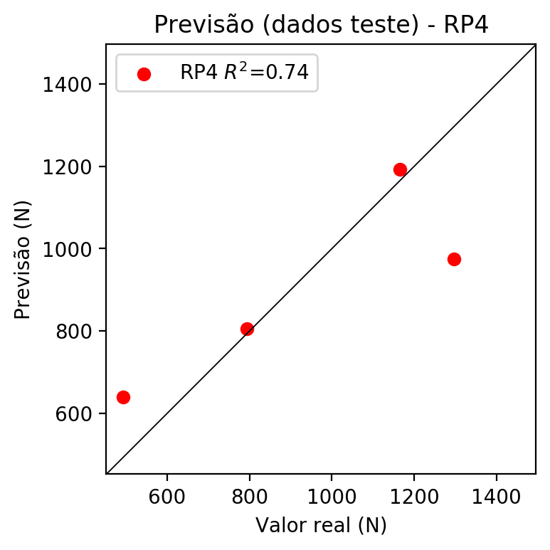

**Dados de treino**

* Erro relativo médio: 0.67
* Coeficiente de correlação: 1.0
* Coeficiente de determinação: 1.0
* MSE: 115.0
* RMSE: 10.72

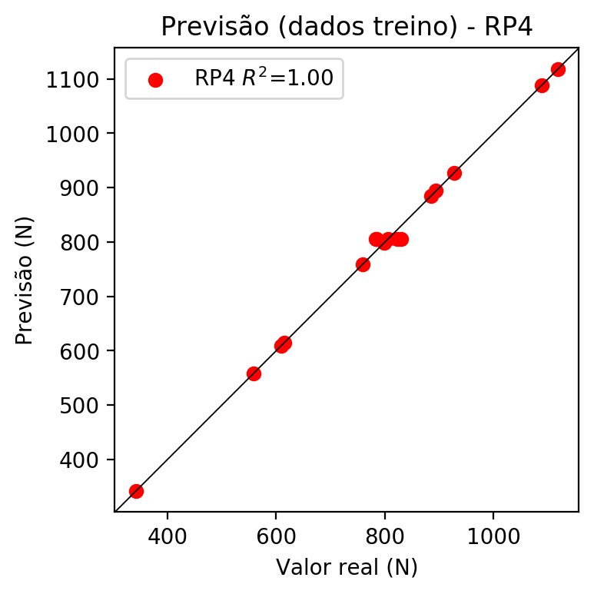

# Geral

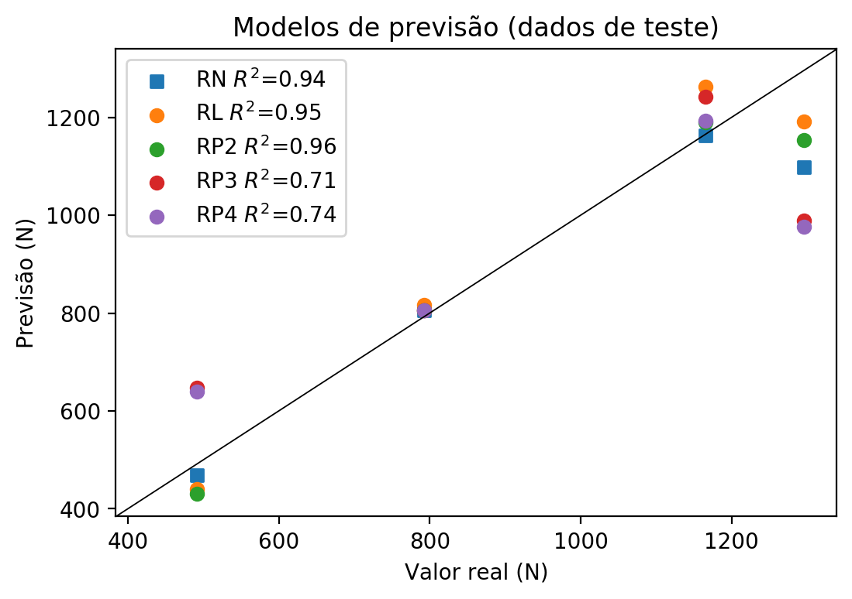

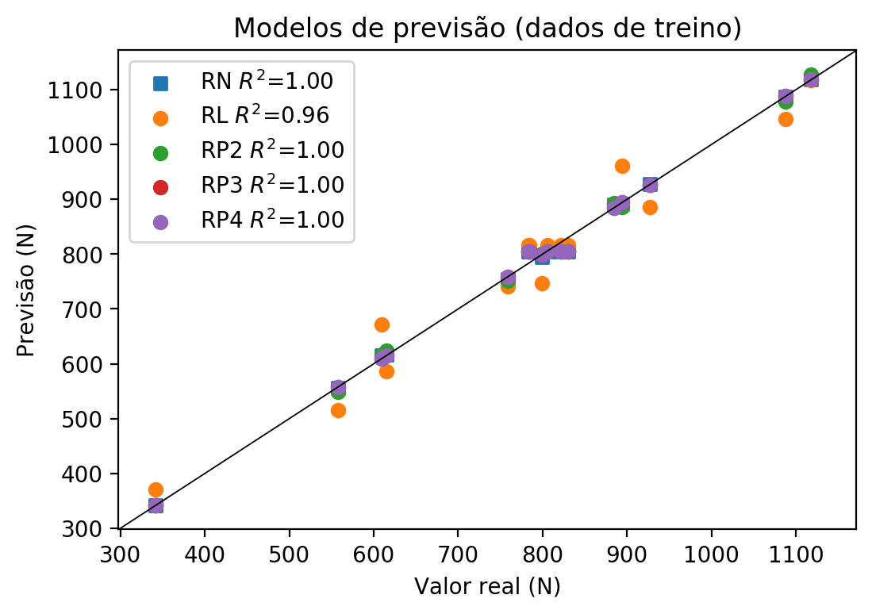

**Dados de teste**

|  |  |  |  |  |  |  |  |  |  |  |
| --- | --- | --- | --- | --- | --- | --- | --- | --- | --- | --- |
| Valor real | RN Previsto | RN Erro (%) | RL Previsto | RL Erro (%) | RP2 Previsto | RP2 Erro (%) | RP3 Previsto | RP3 Erro (%) | RP4 Previsto | RP4 Erro (%) |
| 1165.0 | 1162.32 | 0.23 | 1262.05 | 8.33 | 1189.5 | 2.1 | 1242.55 | 6.66 | 1193.16 | 2.42 |
| 492.0 | 468.07 | 4.86 | 441.02 | 10.36 | 430.75 | 12.45 | 647.69 | 31.64 | 639.71 | 30.02 |
| 1296.0 | 1097.46 | 15.32 | 1192.04 | 8.02 | 1152.75 | 11.05 | 988.85 | 23.7 | 975.7 | 24.71 |
| 793.0 | 805.05 | 1.52 | 816.53 | 2.97 | 805.0 | 1.51 | 805.0 | 1.51 | 805.0 | 1.51 |

**Dados de treino**

|  |  |  |  |  |  |  |  |  |  |  |
| --- | --- | --- | --- | --- | --- | --- | --- | --- | --- | --- |
| Valor real | RN Previsto | RN Erro (%) | RL Previsto | RL Erro (%) | RP2 Previsto | RP2 Erro (%) | RP3 Previsto | RP3 Erro (%) | RP4 Previsto | RP4 Erro (%) |
| 806.0 | 805.05 | 0.12 | 816.53 | 1.31 | 805.0 | 0.12 | 805.0 | 0.12 | 805.0 | 0.12 |
| 1118.0 | 1119.06 | 0.09 | 1117.04 | 0.09 | 1127.62 | 0.86 | 1118.0 | 0.0 | 1118.0 | 0.0 |
| 783.0 | 805.05 | 2.82 | 816.53 | 4.28 | 805.0 | 2.81 | 805.0 | 2.81 | 805.0 | 2.81 |
| 885.0 | 889.81 | 0.54 | 891.53 | 0.74 | 893.38 | 0.95 | 885.0 | 0.0 | 885.0 | 0.0 |
| 615.0 | 616.54 | 0.25 | 586.03 | 4.71 | 624.62 | 1.56 | 615.0 | 0.0 | 615.0 | 0.0 |
| 558.0 | 556.44 | 0.28 | 516.03 | 7.52 | 548.37 | 1.73 | 558.0 | 0.0 | 558.0 | 0.0 |
| 759.0 | 754.34 | 0.61 | 741.53 | 2.3 | 750.63 | 1.1 | 759.0 | 0.0 | 759.0 | 0.0 |
| 894.0 | 891.6 | 0.27 | 961.54 | 7.55 | 885.62 | 0.94 | 894.0 | 0.0 | 894.0 | 0.0 |
| 799.0 | 795.2 | 0.48 | 746.53 | 6.57 | 800.25 | 0.16 | 799.0 | 0.0 | 799.0 | 0.0 |
| 784.0 | 805.05 | 2.68 | 816.53 | 4.15 | 805.0 | 2.68 | 805.0 | 2.68 | 805.0 | 2.68 |
| 1088.0 | 1086.48 | 0.14 | 1047.03 | 3.77 | 1078.38 | 0.88 | 1088.0 | 0.0 | 1088.0 | 0.0 |
| 822.0 | 805.05 | 2.06 | 816.53 | 0.67 | 805.0 | 2.07 | 805.0 | 2.07 | 805.0 | 2.07 |
| 609.0 | 615.36 | 1.04 | 671.53 | 10.27 | 617.38 | 1.38 | 609.0 | 0.0 | 609.0 | 0.0 |
| 342.0 | 341.81 | 0.06 | 371.02 | 8.49 | 342.0 | 0.0 | 342.0 | 0.0 | 342.0 | 0.0 |
| 927.0 | 928.32 | 0.14 | 886.54 | 4.36 | 925.75 | 0.13 | 927.0 | 0.0 | 927.0 | 0.0 |
| 830.0 | 805.05 | 3.01 | 816.53 | 1.62 | 805.0 | 3.01 | 805.0 | 3.01 | 805.0 | 3.01 |